Running Virus Scan
On April 28, 2014 there was a passing mention here: https://www.askwoody.com/forums/topic/windows7-fax-coverpage-garbage/
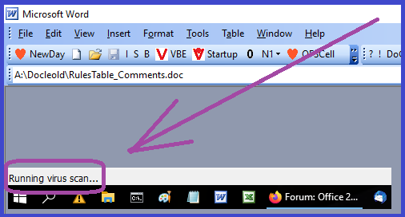
In the first place I'd like to track down exactly which program is delivering the "Running Virus Scan" message.
I run Word2003 because it gives me all I need for programming applications in VBA.
In July 2020 I bought a new laptop with Win10. prior to that I was running Win7, WinXP and so on. I install the same version of Office2003 installed from the original CD (and I can do it again and again) and the 2003 updates "Office2003\Office2003SP3-KB923618-FullFile-ENU.exe" and the FileFormatConverters "20072010Converters/FileFormatConverters.exe". I have sixteen application templates in my Word Startup folder, but these have been stable for years; updated from time to time, but in place.
After Win10 was installed I found that about two times out of ten, when I opened a MSWord document from File Explorer (<Enter> key or Double-Click), the phrase "Running Virus Scan" appeared in my MSWord status bar – and after a wait of about ten seconds the file would fail to load.
Alt-Tab back to Explorer, <Enter>, and the file loads without the status message!
To the best of my knowledge I am running no anti-virus software except for Win10 Defender with automatic updates.
Obviously I would like to be rid of this hurdle without doing a complete re-installation – but I can do a complete re-installation if required.
Some fifteen years ago I had a problem installing my password-protected Utility Template UW.dot on a colleague's machine that sported McAfee. We could not get rid of McAfee and we both wanted to test an application with the locked UW.dot. Stalemate. That is why I am not running (as far as I know) any 3rd-party anti-virus software.
What would generate this status message, and how might I identify the culprit?
Thanks
Chris Greaves

Wednesday, February 03, 2021
February 3, 2021 at 2:20 pm #2340239 Report new
b
Sounds like a leftover from Malwarebytes, Norton or “Endnote” add-in:
Disable “Running virus scan” when starting MS Word (Malwarebytes?)
Disabling “Running virus scan” in Win word
“Running Virus Scan…” question: McAfee the problem?
Check for any add-ins which could be disabled or removed:
How to determine whether any COM add-ins are loaded in Word

Wednesday, February 03, 2021
B, thank you for the rapid response and the action-packed list of things to do. I have set aside three hours tomorrow to start working through the tips methodically and will report back in full. A quick scan of the four links and some of their links suggests packages (Norton, McAfee, AVG) which I have not installed in over ten years, but I know that they might have been installed with some other downloaded application.
And although at least one followed link is in Word10, I see too that the "Running Virus Scan" has been a problem back to at least one other Word2003 installation from (was it?) 2006?
Over the past three months I have detected no pattern in this message, so for me the message is not explicitly reproducible. I will set a threshold of so-many-loads or so-many-days without the message to determine if the problem is solved. That is, this may take some time (grin)
Thanks again for the leads.

Thursday, February 04, 2021
https://www.askwoody.com/forums/users/skiph/
I use Office 2003 on Windows 10 (no snide remarks, please!)
I’ve had this happen to me in the past. This is not related to any A/V you may be running, it happens with the built-in Windows Security app, even if it’s turned off.
The fix that I found after lots of searching on the net was:
Open Word. Click on the Help menu option.
From the drop down menu, select “Detect and Repair…”
When the Detect and Repair window opens, it will look like the attached screen snip.
Click on the “Start” button. It should do its thing very quickly.
Then try to open a Word document. It should open fine. I think this bug also used to affect Excel files. This fix fixes opening Excel files also.
Here’s the link to the web page that has the info on it:
https://word.tips.net/T000316_Cant_Open_a_Word_Document_in_Windows.html
I can’t remember now if I tried any of the other “fixes” on the above web page, but I’ve had to use the Repair process several times, and it works every time. It’s been quite awhile since I had to use it last.
IIRC, if you add or change any parts of Office, like add the File Format Converter, it will re-activate the “bug”. I got hit by it on one system when I thought I had Word running OK, then added the File Format Converter, and it came back.

Thursday, February 04, 2021
Well, I tried this, but was at the café without the CD. I will try again when I get home. I was not asked for the CD, but this message popped up, which sounds to me as if it might be a disguised plea for the CD.
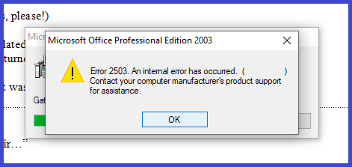
A search " Word2003 Error 2503 an internal error" without quotes brings up a slew of fixes, amongst them:-
https://answers.microsoft.com/en-us/windows/forum/all/internal-error-25032502/28b361b7-b2d7-494d-8470-5969f6850f5a
https://errortools.com/windows/fix-internal-error-2503/
https://www.boxaid.com/blog/how-to-fix-2502-2503-errors/
but I shall wait until I am home and armed with the original installation CD before going ahead.
Uploaded this document to http://chrisgreaves.com/Downloads/RunningVirusScan.doc

Thursday, February 04, 2021
[postquote quote=2340320]
Skip, thanks for this idea. I tried it immediately but got a "2503 Error", and a web search turned up suggestions. I suspect that trying this fix in the cafe without my original installation CD. I shall wait until I am home, then try again.
In the meantime, I have uploaded http://chrisgreaves.com/Downloads/RunningVirusScan.doc and will upload a revised copy each time I explore, just to avoid cluttering up this exotic thread with tons of text and images!
Cheers

Thursday, February 04, 2021
***
Your message was blocked. Please contact the administrator via sb@askwoody.com
*** Forbidden. Your IP belongs to a high spam risk network. Please, try again without VPN. ***

Thursday, February 04, 2021
https://www.askwoody.com/forums/users/doriel/
I ran into same issue last week with my Excel 2010. It hang while “virus scan” message exactly as yours.
My workaround?
There were failing Defender updates waiting in the queue.
1 – I stopped “Windows Update Service” in computer management.
2 – Quickly rename
C:\Windows\Softwaredistribution
to
C:\Windows\Softwaredistribution.old
3 – Check for updates again.
4 – Install them.
5 – Launch Excel as administrator (rightclick Excel and “Run as Administrator”) – open failing file.
Now all should work as before.. It worked for me, hope this will help. I think it has something to do with the virus definitions..

Friday, February 05, 2021
SkipH: While reading Doriel’s post, it reminded me that another thing that running Word 2003 and Excel 2003 might have needed to be done was to run either of those programs from the .EXE file in the installation directory as “Administrator” at least one time, or I vaguely remember it asking to be activated every time it was started. It’s been awhile since I installed it on my system, sorry I can’t remember exactly
On my system (Windows 10 Pro, 1909, Build 18363.1316), the main Office files are in:
C:\Program Files (x86)\Microsoft Office\OFFICE11
Find the “WinWord.EXE” file in the OFFICE11 folder, right-click on it, then select “Run as administrator” from the menu, and OK that process. Neither of the programs (Word or Excel) can be “run as administrator” from the default shortcuts that are created when installing the programs, there’s no option for that on the right-click menu for their icons.
Then, when Word (or Excel) is running as “administrator”, I think Chris might have success in doing the “Detect and Repair…” process.
As for needing the original installation CD…on my system, installing Office 2003 made an “MSOCache” folder in the root of the C: drive, so the files needed to uninstall, change or repair the Office programs are located on the C: drive.
I never had to do any of the other suggested “fixes” that others have been posting…doing a “Detect and Repair…” from the Help menu fixed it every time.

Friday, February 05, 2021
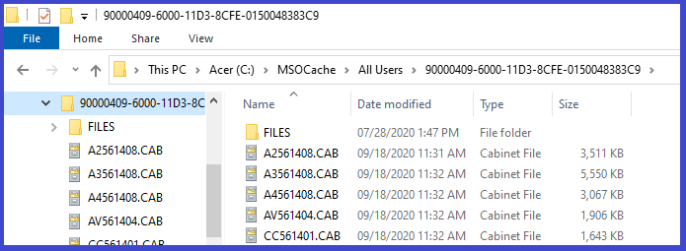

Friday, February 05, 2021
My acceptance test will be a week running without encountering the message (and delay) in "Running Virus Scan"
From RunniL2S2062WednesdayFeb I postpone the question of checking for virus scanners. They may be present and I should check, but later messages suggest a problem with Word2003 and/or Defender, and these are faster fixes for now.
From RunniL2S4191ThursdayFebr Skiph a suggestion that I repair Word2003 installation. This I will try. I would rather not re-install Word2003, because I would have to do that if I were to reinstall Win10, so why not wait until then.
From RunniL2S7569ThursdayFebr Doriel suggested a problem with Defender,

Monday, February 08, 2021
Two days have passed since my first essay – Updating Windows Defender. I still see the status bar message "Running Virus Scan" but only for part of a second. I can certainly live with that. This does not mean that "defender" is The Fix, only that this fix appears top work for my system.
I shall monitor the situation and report back here if ""Running Virus Scan" appeared in my MSWord status bar – and after a wait of about ten seconds the file would fail to load." Raises its ugly head again.
---/---

